**Name – Parag Gattani**

Program No. – 13

Program Title – IR based SERVO Motor controller

**AIM**

Design IR based SERVO Motor controller. (Clockwise and CounterClockwise rotation of shaft).

**HARDWARES REQUIRED**

* Arduino Board, Breadboard Small,
* IR Sensor, IR Remote, Micro Servo

**CIRCUIT DIAGRAM**

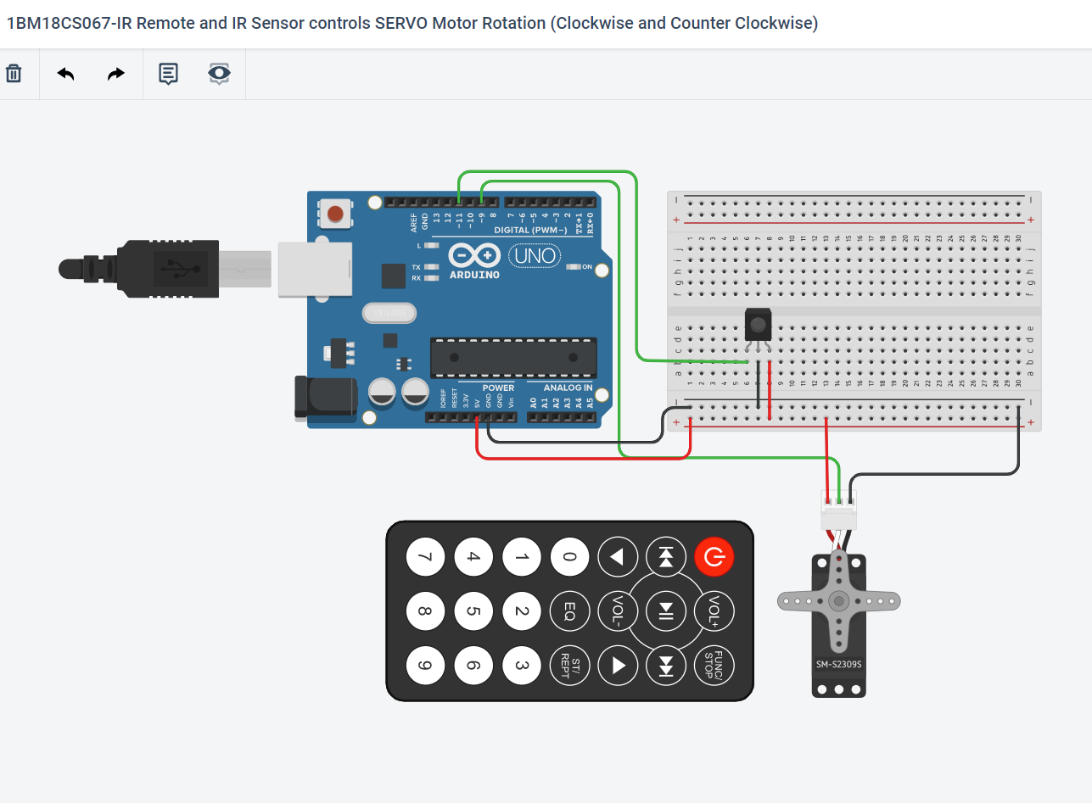

**WRITE-UP**

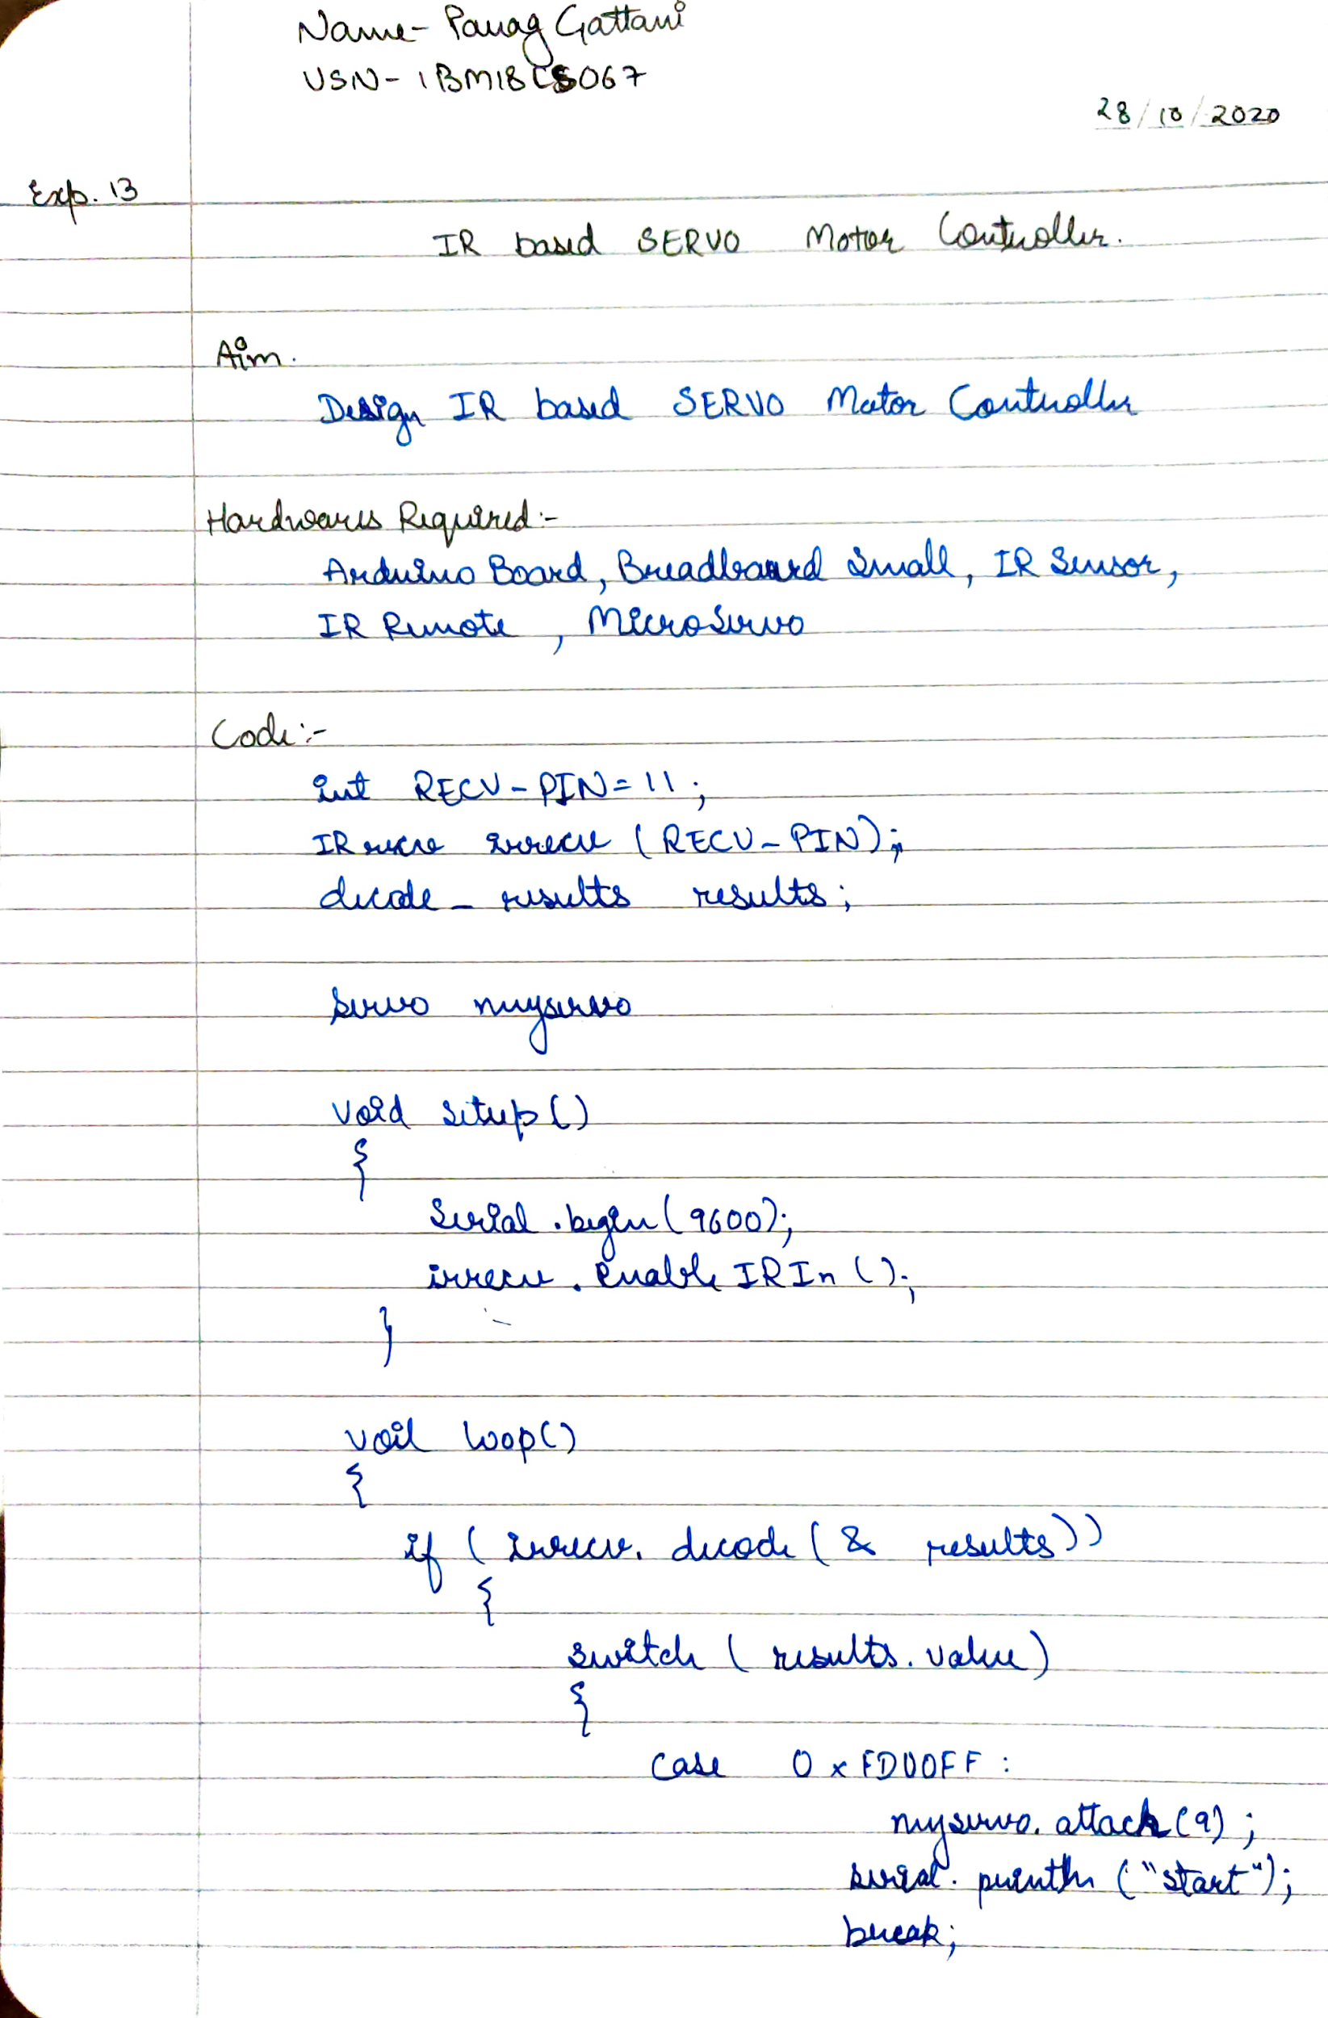

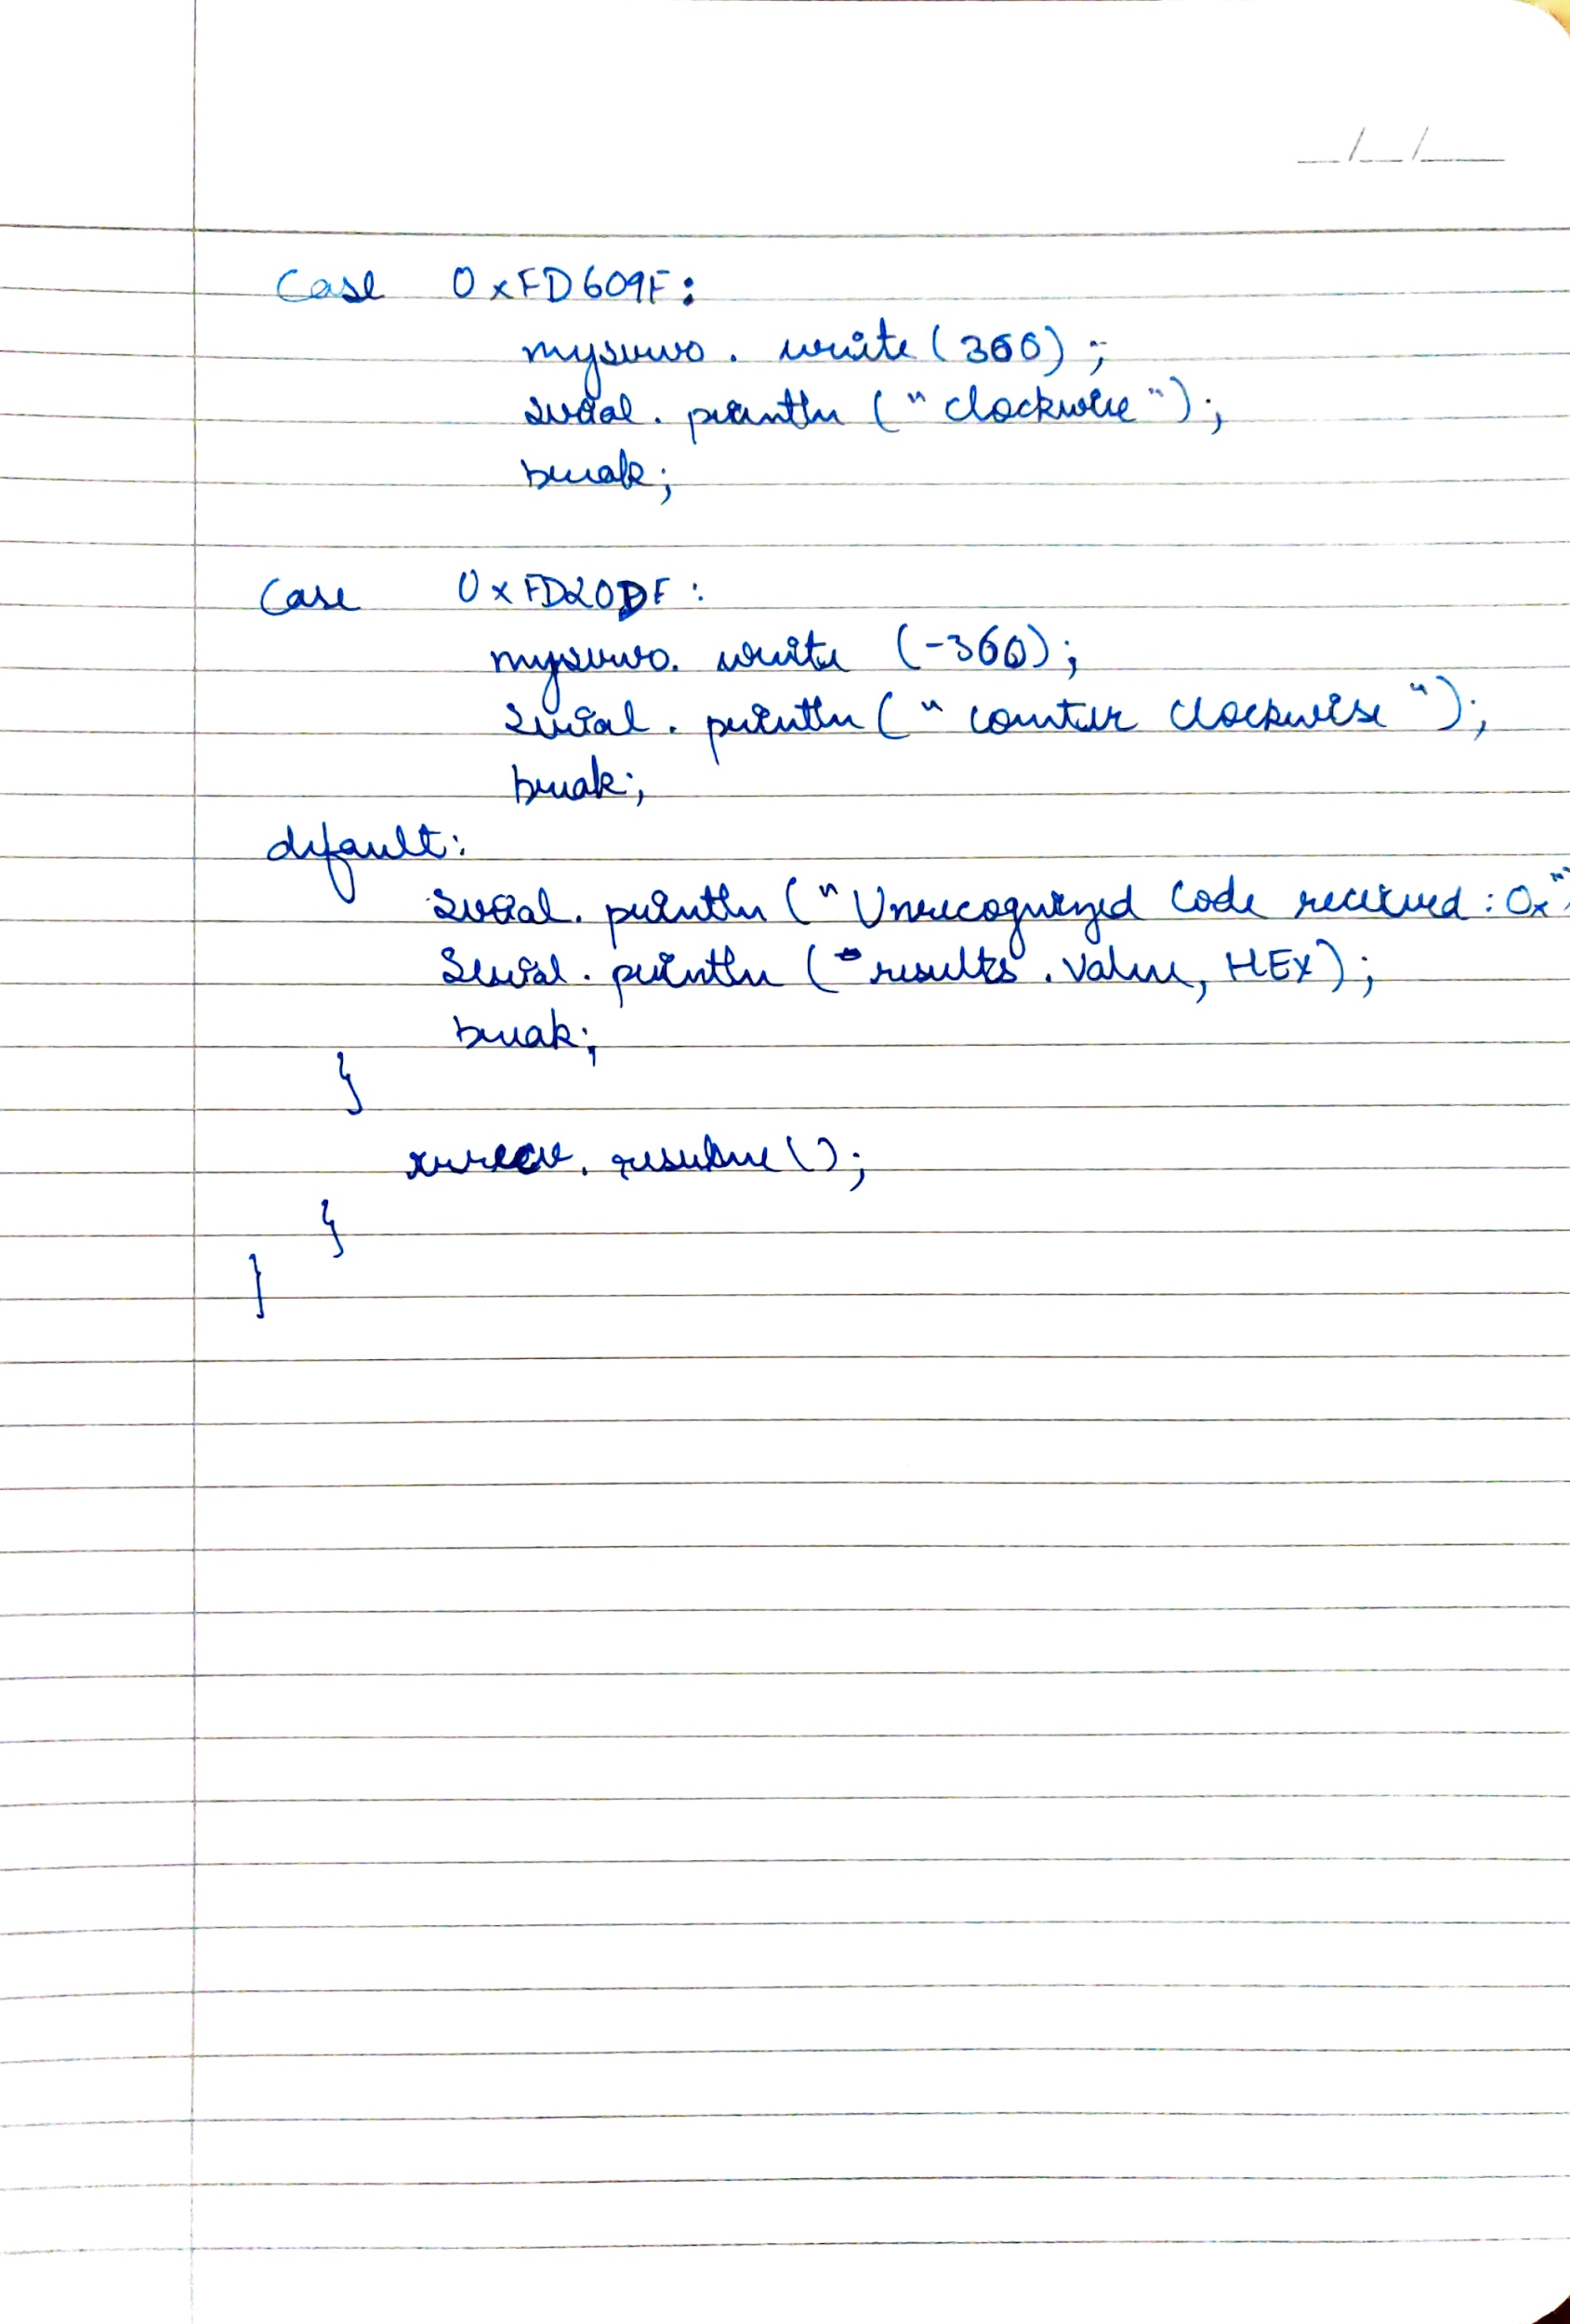

**CODE**

#include <Servo.h>

#include <IRremote.h>

int RECV_PIN = 11;

IRrecv irrecv(RECV_PIN);

decode_results results;

Servo myservo;

void setup(){

Serial.begin(9600);

irrecv.enableIRIn();

}

void loop(){

if (irrecv.decode(&results))

{

switch (results.value)

{

case 0xFD00FF:

myservo.attach(9);

Serial.println("Start");

break;

case 0xFD609F:

myservo.write(360);

Serial.println("Clockwise");

break;

case 0xFD20DF:

myservo.write(-360);

Serial.println("Counter Clockwise");

break;

default:

Serial.print("Unrecognized code received: 0x");

Serial.println(results.value, HEX);

break;

}

irrecv.resume();

}

}

**OUTPUT**

Designed a Smart Package handling system using Tilt Sensor and LED.